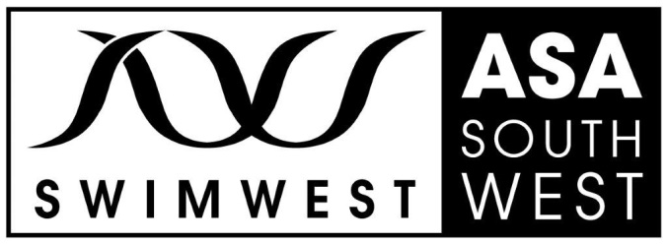
REGIONAL SWIMMING COMMITTEE FUNDING
The Regional Swimming Committee funds which can be applied for under the headings below.

Application forms should be returned to
Christina Tremellen
17 Barrow View, Ferndown, BH22 9SY or
email to christremellen@btinternet.com.

Suggested areas for funding:

- Training days. These must :
*involve a minimum of 3 clubs
*show a pathway
*show coaching development

- Coach education sessions – seminars / skill development

- Parent education sessions

- Support for clubs holding 800/1500m events that are held as discrete galas.
Claims may be made for pool hire during racing and warm up, timing hire, officials
mileage, awards

- Funding is only available for speed swimming, disability & masters

- Funding is not available for competition with the exception of long distance events (see 4.) nor overseas training camps

- Funding is available for up to 50% for Swim 21 clubs (or working towards)
Funding up to 25% for others.

We reserve the right to refuse funding.

ASA SOUTH WEST REGION
SWIMMING COMMITTEE FUNDING APPLICATION FORM
(Licence Fee Fund)
CLUB
CONTACT NAME
TELEPHONE
EMAIL ADDRESS
Details of Application
Proposed activity
(detailed information for swimmers training sessions required below)
Proposed dates
Proposed venue
Proposed attendees eg swimmers/coaches/parents
Clubs involved
Lead person
Estimated costs
Estimated income
Swimmers Training Sessions only
Number & purpose of training session(s)
Standard of swimmers targeted
Clubs involved.
Note: swimmers from a minimum of 3 clubs to be included

How many swimmers will attend from each club, please list numbers.

Swimmers age range
Number of coaches involved and their clubs

Will coach mentoring be included. Please give details

Expected expenditure. Please list details

Expected income
TOTAL FUNDING REQUESTED

